|  |  |  |  |  |
| --- | --- | --- | --- | --- |
|  | **Will the user know what to do at this step?** | **Is the control visible?** | **Is feedback appropriate?** | **What learning issues will the user have?** |
| Click on SignUp button | Yes | Yes | Yes | N/A |
| Type in your new username | Yes | Yes | Yes | N/A |
| Click on Generate Password | Yes | Yes | Yes | N/A |
| Click on SignUp button | Yes | Yes | Yes | N/A |

Goal: **To create my own password**

**Goal: Login with new password**

|  |  |  |  |  |
| --- | --- | --- | --- | --- |
|  | **Will the user know what to do at this step?** | **Is the control visible?** | **Is feedback appropriate?** | **What learning issues will the user have?** |
| Click on Text Field | Yes | Yes | Yes | None |
| Type on text box for Username | Yes | Yes | Yes | None |
| Click on Text Field | Yes | Yes | Yes | None |
| Type on text box for Password | Yes | Yes | Yes | None |
| Click on Log-in | Yes | Yes | Yes | None |

**Goal: Display the time**

|  |  |  |  |  |
| --- | --- | --- | --- | --- |
|  | **Will the user know what to do at this step?** | **Is the control visible?** | **Is feedback appropriate?** | **What learning issues will the user have?** |
| **Click “Time” button** | **Yes** | **Yes** | **Yes** | **N/A** |

**Goal: Exit Program**

|  |  |  |  |  |
| --- | --- | --- | --- | --- |
|  | **Will the user know what to do at this step?** | **Is the control visible?** | **Is feedback appropriate?** | **What learning issues will the user have?** |
| **Click “Quit” button** | **Yes** | **Yes** | **Yes** | **N/A** |

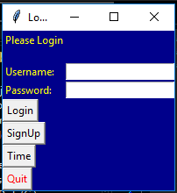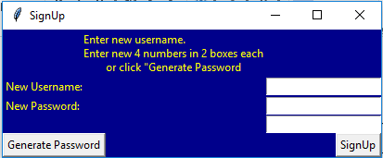

This interface tells the user to enter the new credentials, generate password and sign-up

This interface tells the user to enter the details, login, sign-up, check the time or quit.

Heuristics

**Is the dialogue suitable for the user’s task and skill level?**

The dialogue is suitable for the user’s task and skill level as the interface is easy-to-use and fit for purpose. There is nothing complex about this interface so any can use it.

**Does the dialogue make it clear what the user should do next?**

The dialogue make is clear what the user should do next as the language used to communicate with the user is clear and understandable.

**Is the dialogue consistent?**

The buttons and the labels are named consistent so that the user has an idea of what they are doing and where they are.

**Does the dialogue support learning?**

The sign-up page shows a message explain to the user how to create a secure password.

**Can the user control the pace and sequence of the interaction?**

A timer is not required. The user is allowed to take as much time as they want to create a username and a password.

**Is the dialogue forgiving?**

When the user is logging in, if the credentials are incorrect then the dialogue would display an error message.

**Can the dialogue be customised to suit the user?**

The dialogue does not need to be customized as it is just a simply log-in system.